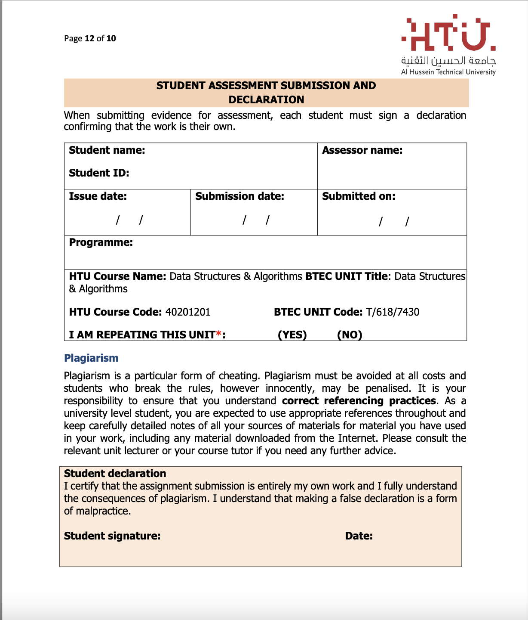

18/6/2023



18/6/2023

Saif haddad

Eng.Dania al saed

Saif kamal salim haddad

21110214